**DAILY ONLINE ACTIVITIES SUMMARY**

|  |  |  |  |  |  |  |  |  |
| --- | --- | --- | --- | --- | --- | --- | --- | --- |
| **Date:** | **26-05-2020** | | | | | **Name:** | **Kanaka BS** | |
| **Sem & Sec** | **6th - A** | | | | | **USN:** | **4AL17CS039** | |
| **Online Test Summary** | | | | | | | | |
| **Subject** | | **CGV-II** | | | | | | |
| **Max. Marks** | | **30** | | **Score** | | | **20** | |
| **Certification Course Summary** | | | | | | | | |
| **Course** | **Complete Python Developer in 2020** | | | | | | | |
| **Certificate Provider** | | | **Udemy** | | **Duration** | | | **30 hours** |
| **Coding Challenges** | | | | | | | | |
| **Problem Statement: Python, java and C Programs** | | | | | | | | |
| **Status: executed** | | | | | | | | |
| **Uploaded the report in Github** | | | | | **yes** | | | |
| **If yes Repository name** | | | | | <https://github.com/kanakabs/Daily-Status/tree/master/26-05-20/online%20coding> | | | |
| **Uploaded the report in slack** | | | | | **Yes** | | | |

Online Test Details:

II-IA of CGV

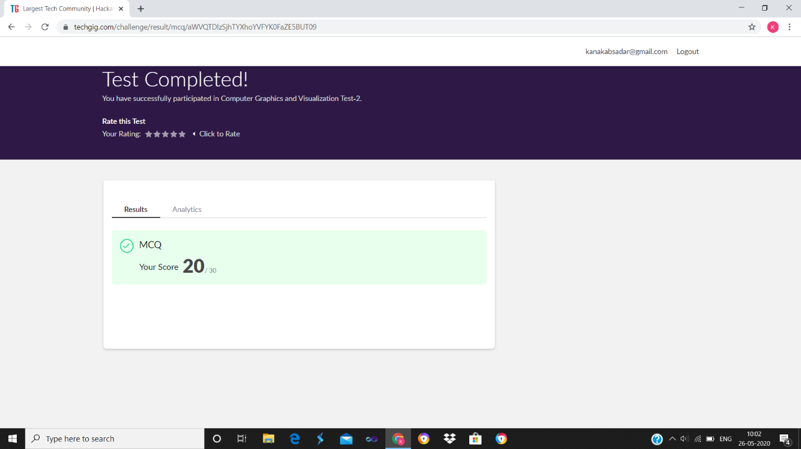

Certification Course Details:

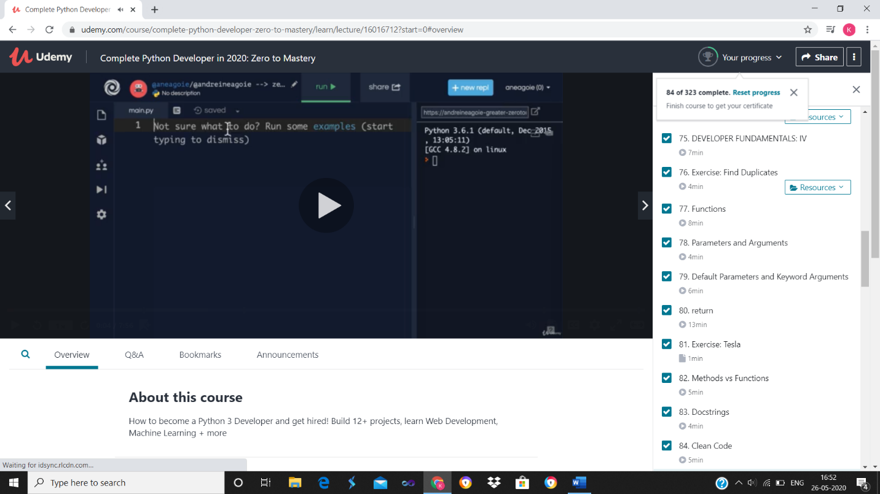

Coding Challenges Details available in the below link

<https://github.com/kanakabs/Daily-Status/tree/master/26-05-20/online%20coding>